**Vision Document for “Banking System”**

**Team members:**

**XSron Hou 986427**

**Bereket Gebremeskel 610719**

**1. Introduction**

**The MIB (Maharishi International Bank)** is bank which provide a Banking System in a convenient way for the student and staff to have an easy access to a bank right here on campus without going to the other external bank. The functionality of the system includes create bank account, deposit, withdraw, transfer, utility payment, loan operation to the student and salary payment to the staff.

**2. Positioning**

**2.1 Problem Statement**

|  |  |
| --- | --- |
| The problem of | * Depending on an external bank to give out loan to student. * Access to a bank for students that don’t have transportation to go to an external bank off-campus. * Complicated way of paying for utilities by going to the bank or the utility office directly. * Expense of paycheck fee for each employee to the bank |
| Affects | *university, staffs, and students* |
| the impact of which is | *Dealing with external bank is complex to give out loan for student, not easily accessible for student, spending additional fee on paying the paycheck to staff and hard for staff and students to pay their utilities.* |
| a successful solution would be | * *Eliminate dependency to an external bank to give out loan for students to attend MIU.* * Provide an easy access to a bank for students right here on campus. * Eliminate additional fee on paying the paycheck to staff |

**2.2 Product Position Statement**

For Staffs and students who need to perform banking operations right here on campus which name is MIBS (Maharishi International Banking System) that Provide an easy access to a bank for student and staff and convenience way for the university to manage student loan unlike Depending on the external bank for all these functionalities. Our product provides a special loan package to the student such as low interest rate, flexible payment plan that is tailored to a specific need of the students.

|  |  |
| --- | --- |
| For | *Staffs and students* |
| Who | Need to perform banking operations right here on campus |
| The (product name) | *MIBS (Maharishi International Banking System)* |
| That | *Provide an easy access to a bank for student and staff and convenience way for the university to manage student loan* |
| Unlike | *Depending on the external bank for all these functionalities.* |
| Our product | *Provide a special loan package to the student such as low interest rate, flexible payment plan that is tailored to a specific need of the students.* |

**3. Stakeholder Descriptions**

**3.1 Stakeholder Summary**

|  |  |  |
| --- | --- | --- |
| **Name** | **Description** | **Responsibilities** |
| Admins | Admin can set and update interest rate, add, delete, update, view staff and user information. | Admin are responsible for setting up, insert initial data and managing system. |
| Teller | Teller can create an account, manage transaction and utility payment. | Tell are responsible for assisting customer for different banking operation. |
| Staff | Staff can make a transfer between account, view transaction history, received paycheck and make a utilities payment. | Staffs are responsible for controlling their transactions. |
| Student | Student can make a transfer between account, view transaction history and utilities payment. | Student are responsible for controlling their transactions. |
| Developer | Developers developer system on the basis of given document. | Developers are responsible for developing system features, fixing bus, and maintaining the system’s availability. |
| Tester | Testers use JUnit tool to test system or integration test | Testers are responsible for integration testing. |

**3.2 User Environment**

*[Detail the working environment of the target user. Here are some suggestions:*

*Number of people involved in completing the task? Is this changing?*

*How long is a task cycle? Amount of time spent in each activity? Is this changing?*

*Any unique environmental constraints: mobile, outdoors, in-flight, and so on?*

*Which system platforms are in use today? Future platforms?*

*What other applications are in use? Does your application need to integrate with them?*

*This is where extracts from the Business Model could be included to outline the task and roles involved,*

*and so on.]*

**4. Product Overview**

**4.1 Product Perspective**

*[This subsection of the* ***Vision*** *document puts the product in perspective to other related products and the*

*user’s environment. If the product is independent and totally self-contained, state it here. If the product is a*

*component of a larger system, then this subsection needs to relate how these systems interact and needs to*

*identify the relevant interfaces between the systems. One easy way to display the major components of the*

*larger system, interconnections, and external interfaces is with a block diagram.]*

**4.2 Assumptions and Dependencies**

*[List each factor that affects the features stated in the* ***Vision*** *document. List assumptions that, if changed,*

*will alter the* ***Vision*** *document. For example, an assumption may state that a specific operating system will*

*be available for the hardware designated for the software product. If the operating system is not available,*

*the* ***Vision*** *document will need to change.]*

**4.3 Needs and Features**

*[Avoid design. Keep feature descriptions at a general level. Focus on capabilities needed and why (not*

*how) they should be implemented.]*

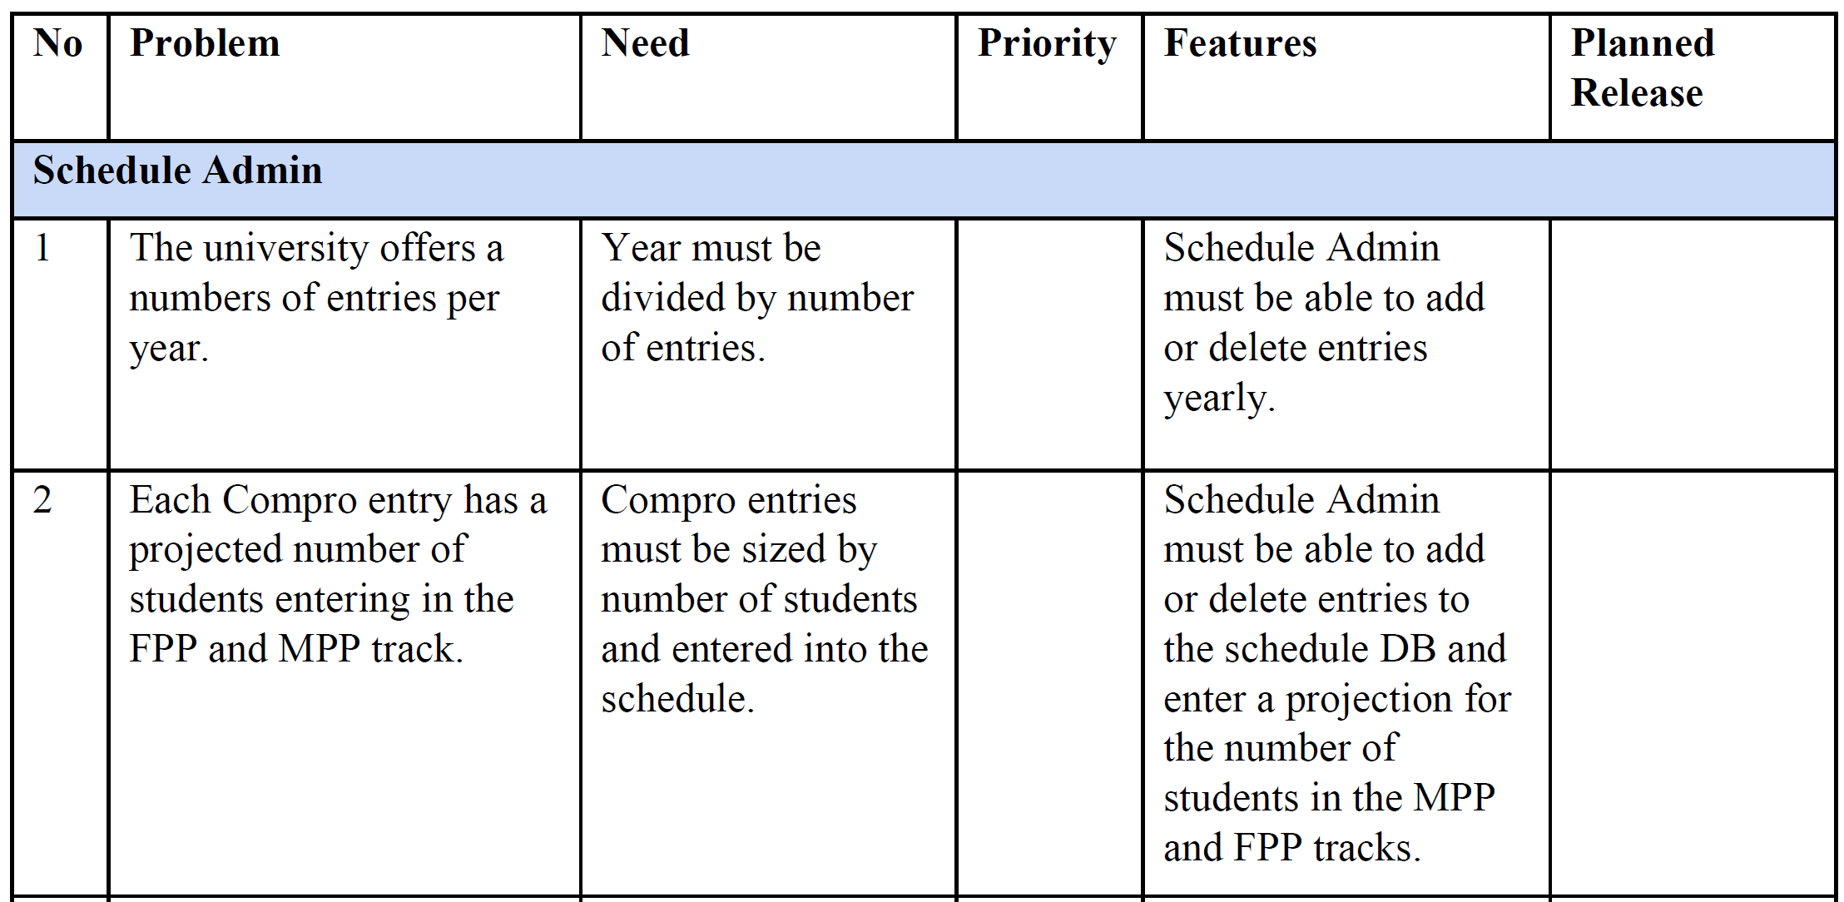

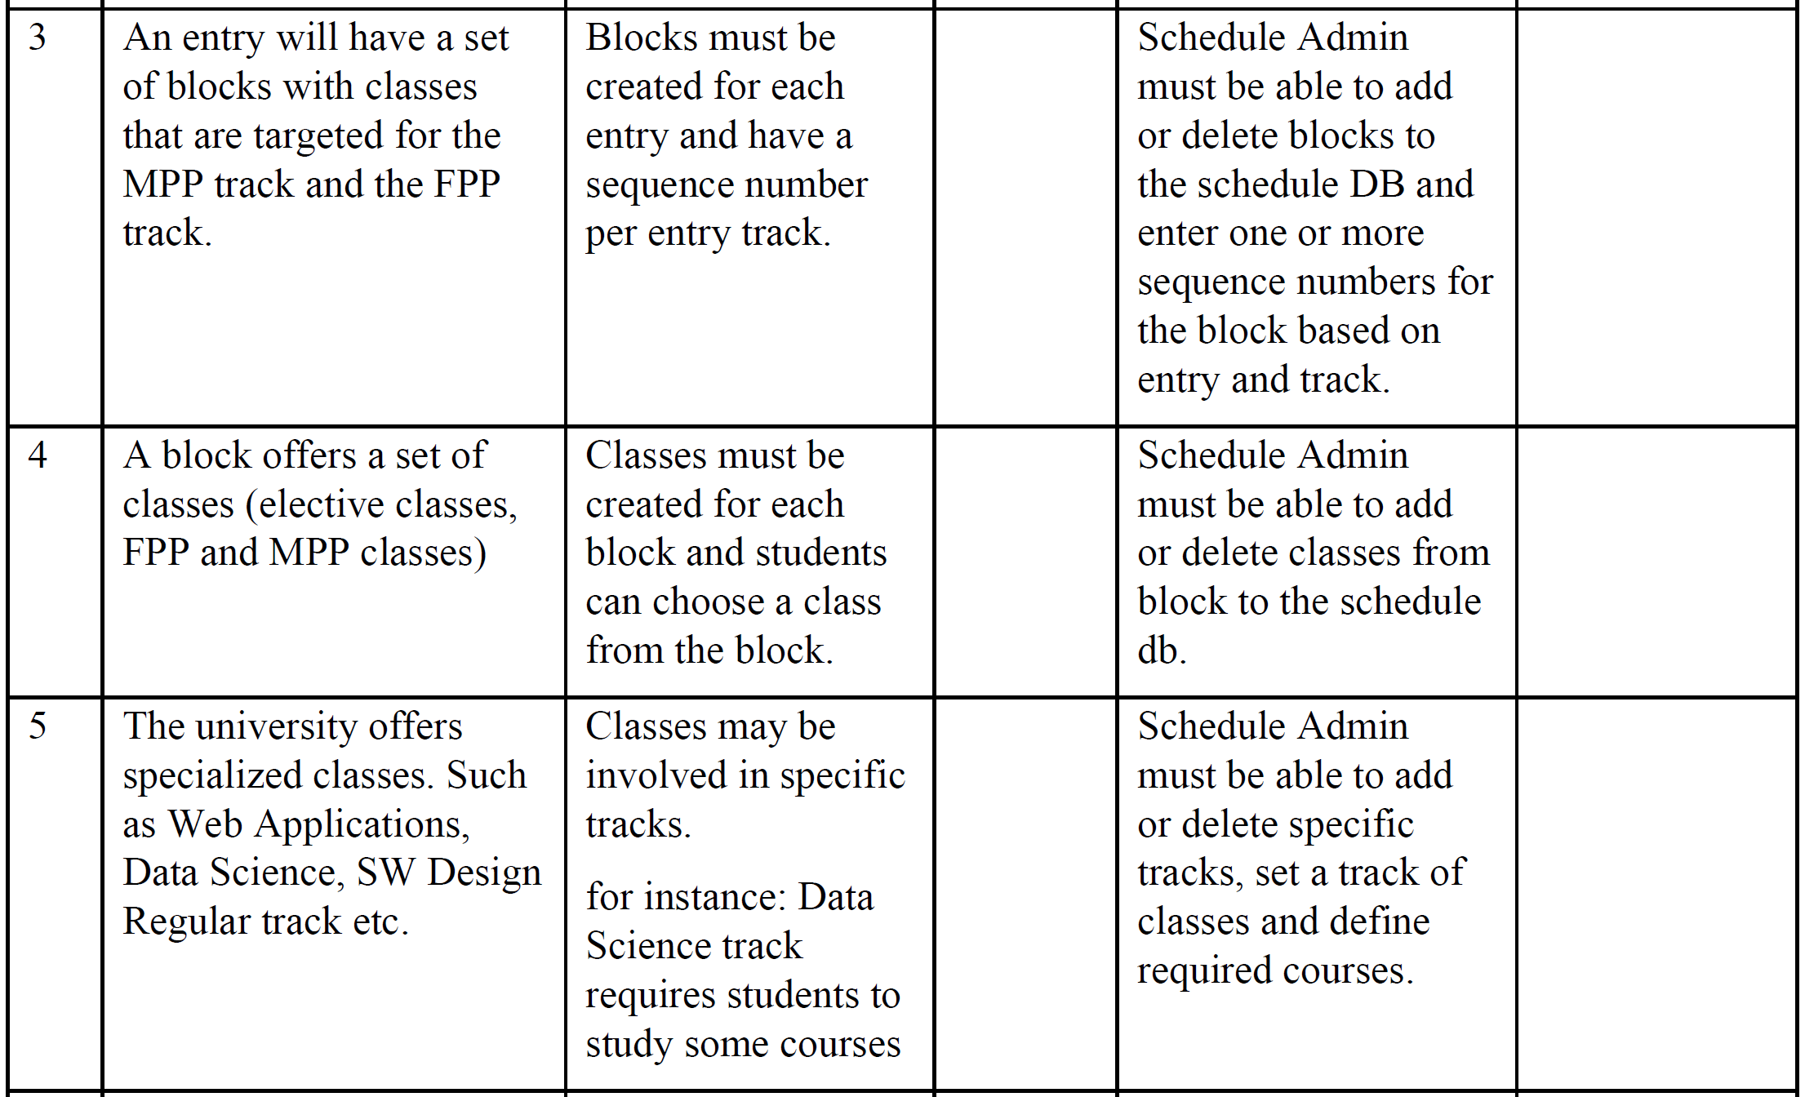

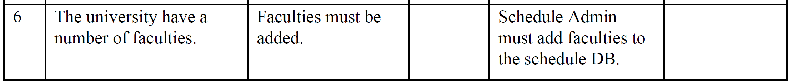

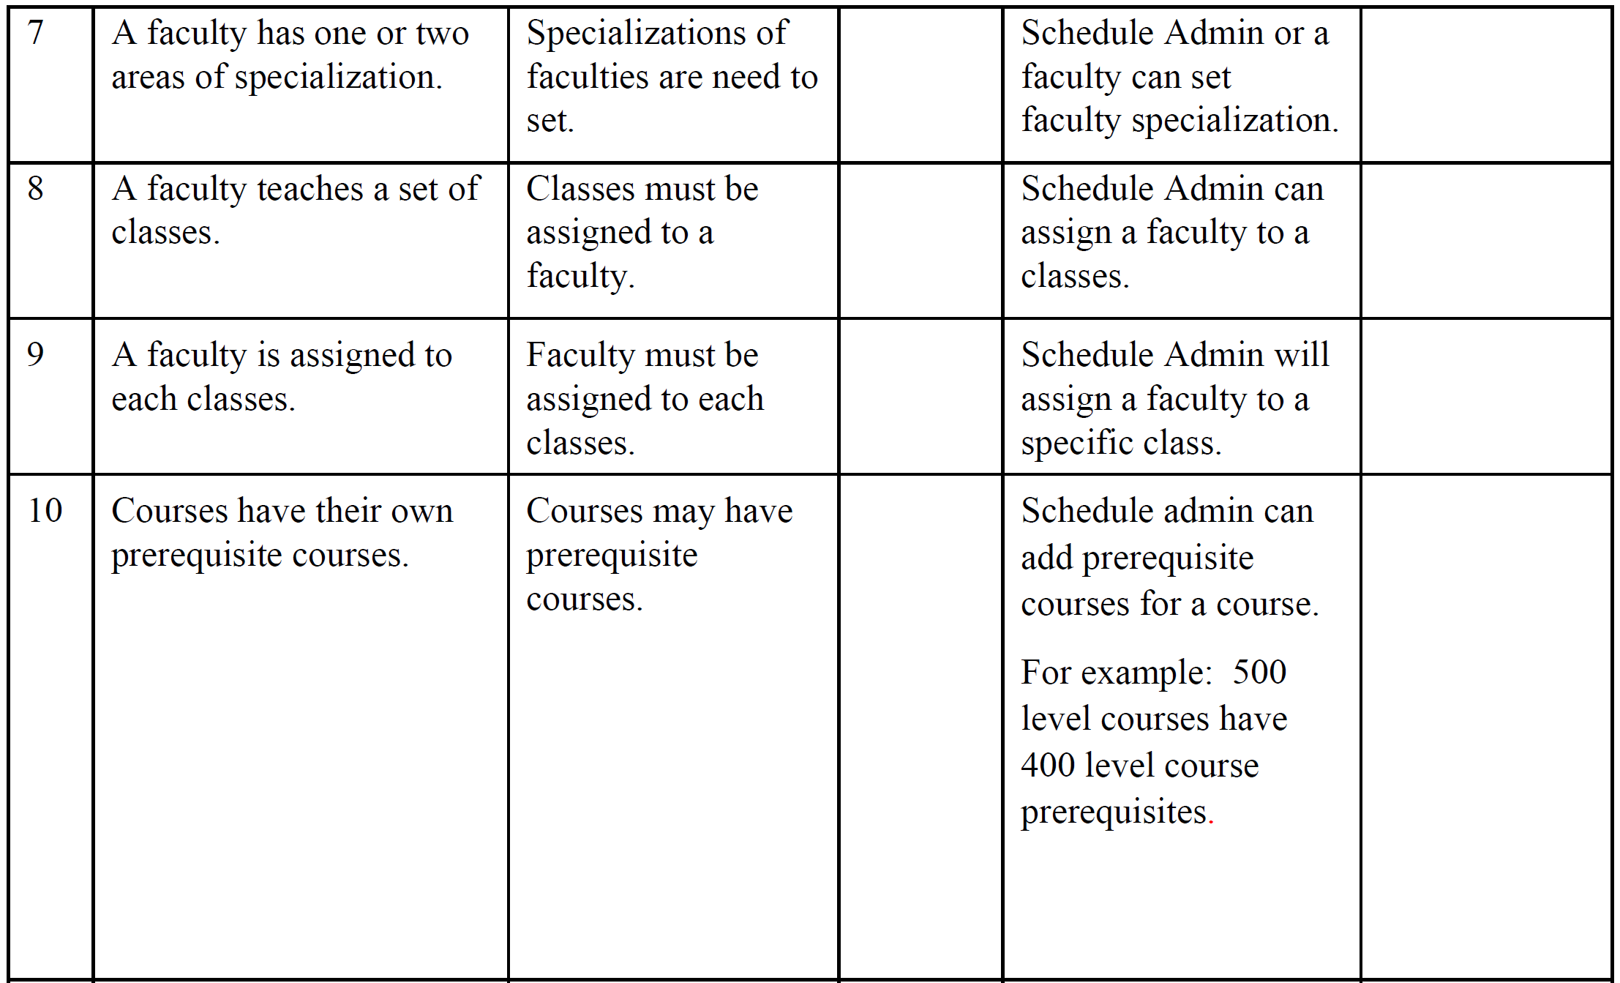

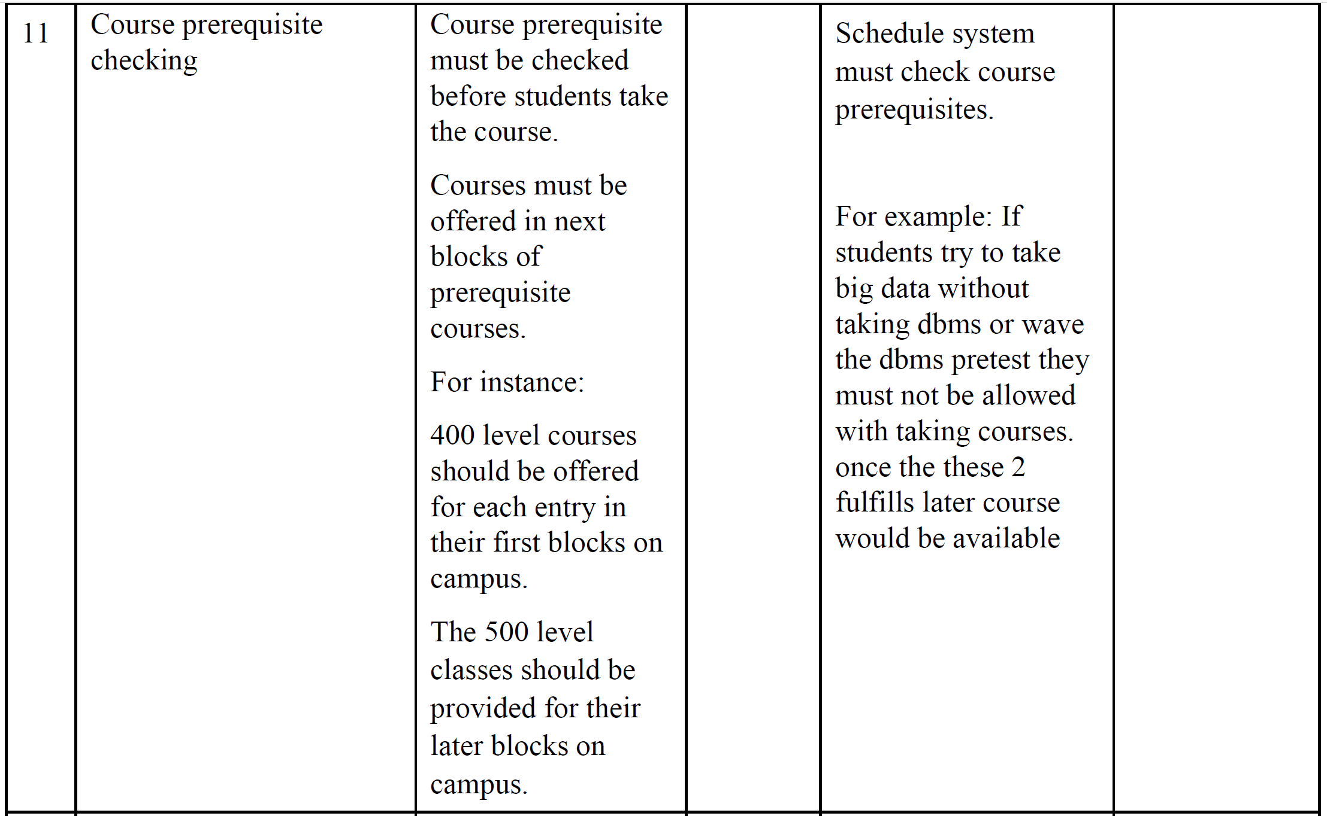

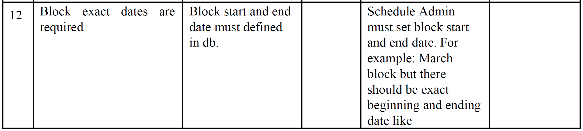

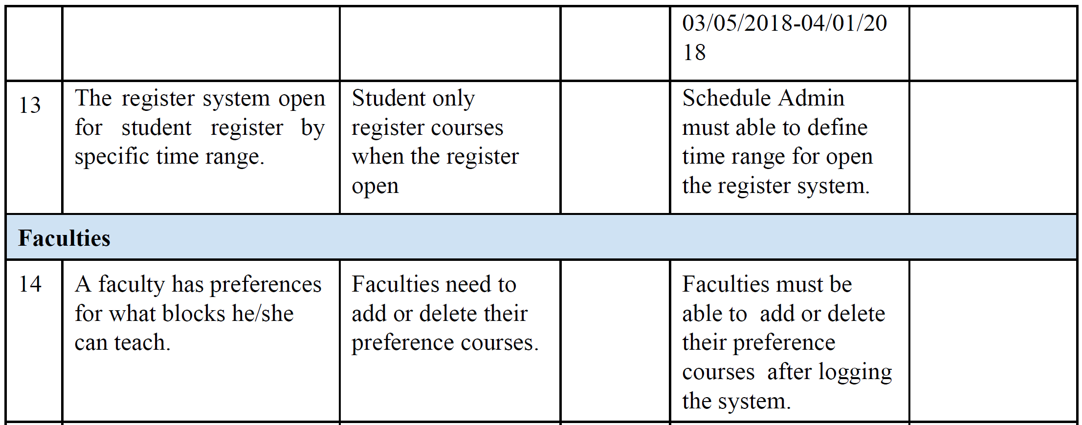

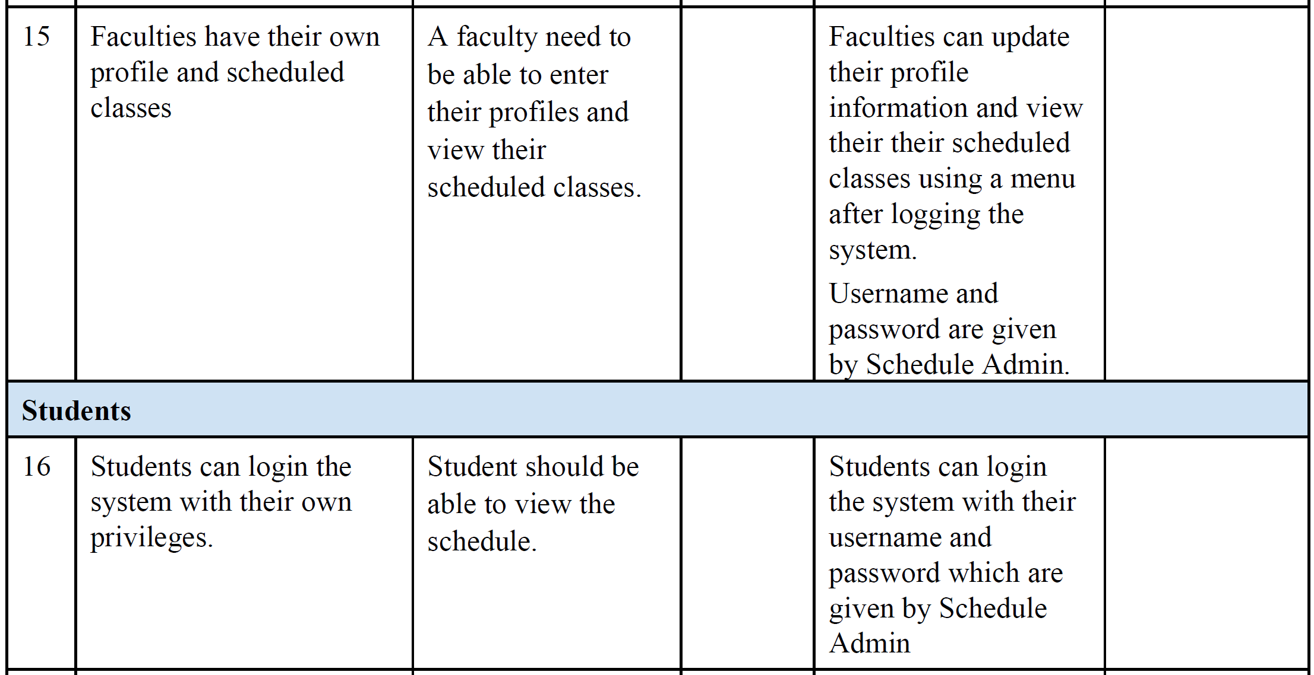

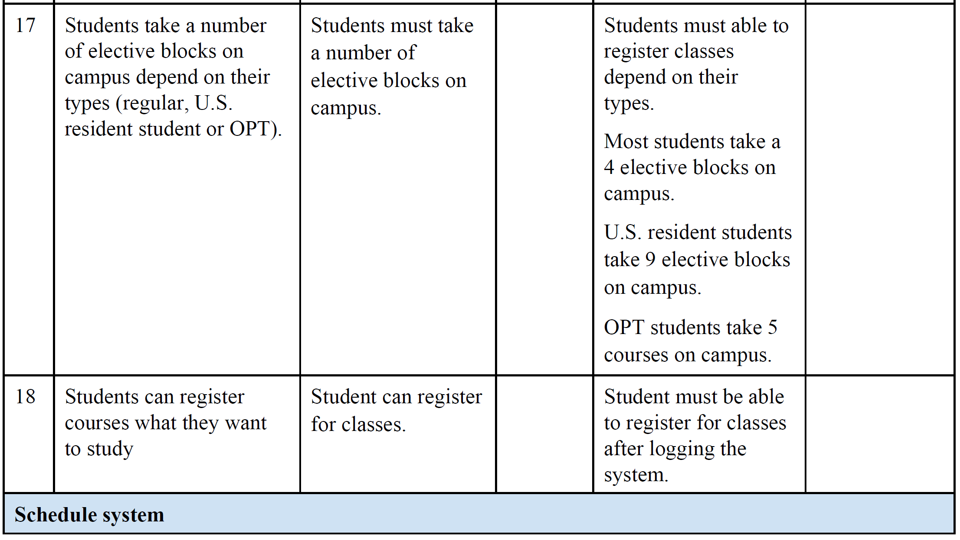

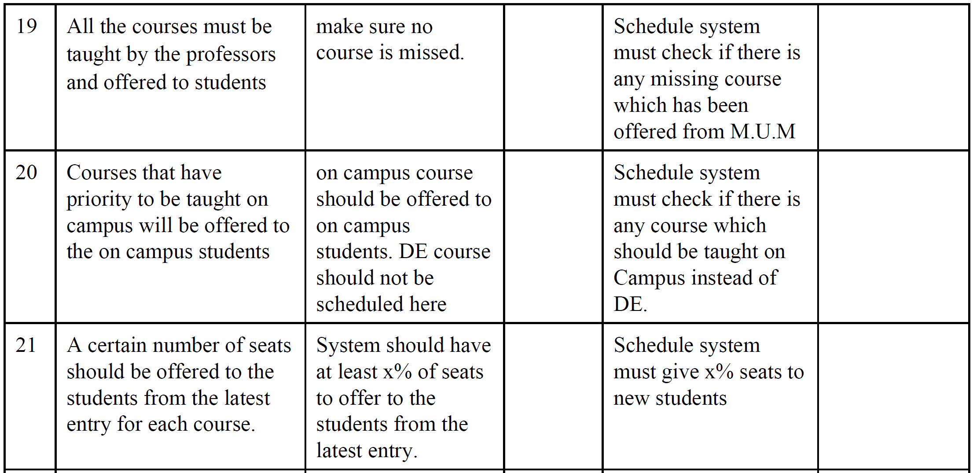

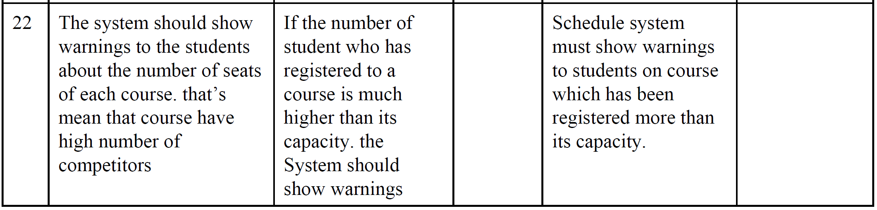

**4.4 Alternatives and Competition**

*[Identify alternatives the stakeholder perceives as available. These can include buying a competitor’s*

*product, building a homegrown solution, or simply maintaining the status quo. List any known competitive*

*choices that exist or may become available. Include the major strengths and weaknesses of each competitor*

*as perceived by the stakeholder or end user.]*

**5. Other Product Requirements**

*[At a high level, list applicable standards, hardware, or platform requirements; performance requirements;*

*and environmental requirements.*

*Define the quality ranges for performance, robustness, fault tolerance, usability, and similar*

*characteristics that are not captured in the Feature Set.*

*Note any design constraints, external constraints, or other dependencies.*

*Define any specific documentation requirements, including user manuals, online help, installation,*

*labeling, and packaging requirements.*

*Define the priority of these other product requirements. Include, if useful, attributes such as stability,*

*benefit, effort, and risk.]*